**TIM 125/225: MOT II: Homework 1**

**(Supply Chain Basics)**

**Reading**:

|  |  |
| --- | --- |
| **Source** | **ASSIGNMENT** |
| TIM-125/225 webpage: | “*Apple's Supply-Chain Secret? Hoard Lasers*" |
| TIM-125/225 webpage: | “*Getting Started with Excel*” |
| TIM-125/225 webpage: | *“Excel Tutorial”* |
| C&M, SCM, 4th edition: | Chapters 1, 2, 3; 16.1, 16.2 |

**Problems (due Thursday, 17 January, 2019):**

In general, the solution for each problem below should proceed in the following stages: (1) define the problem; (2) plan the treatment of the problem, i.e., the way in which you are going to structure your analyses in order to solve the problem, etc.; (3) execute the plan; (4) draw conclusions (e.g., “what was the point of the problem”, etc.).

1. **SCM software vendors:**
2. How large ($, % annual growth rate) is the SCM enterprise-software market?
3. Do a competitive analysis of the business landscape for SCM enterprise-software using Porter’s five (six) forces framework.
4. Then, characterize the competitive strategy of the major firms competing in this space.
5. If you were to enter this space, i.e., be a “new entrant”, what would your strategy be? Explain.
6. **Supply chain strategy for digital camera manufacturers:**
7. Do a competitive analysis of the business landscape for digital cameras using Porter’s five (six) forces framework.
8. Then, characterize the competitive strategy of the major players using the 2x2 grid of “strategic target” and “source of competitive advantage”.
9. What should the corresponding supply chain strategy of each player be in order to achieve the “right” fit with the player’s competitive strategy?
10. Develop a supply chain network for a digital camera.
11. **D 1.2 (discussion problem 2 in Chapter 1)**

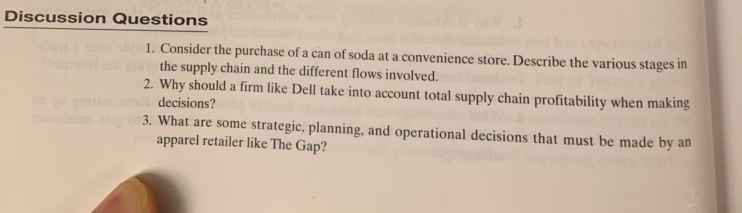

1. **D 1.5, 1.6**

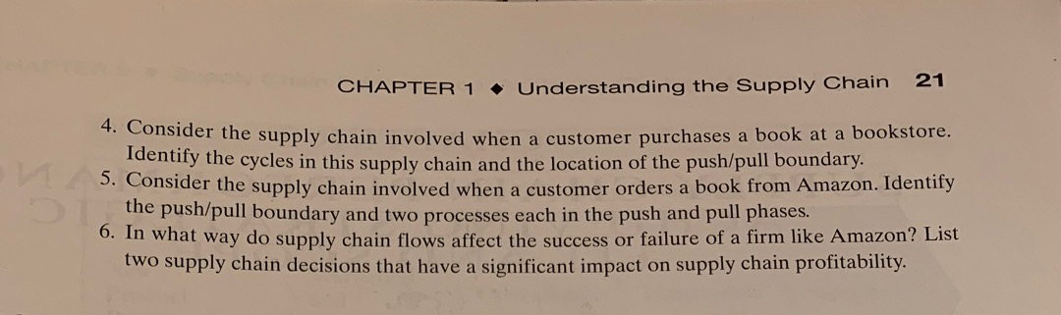

1. **Developing Intermediate-level Microsoft Excel skills:**

**Step 0**: Be sure to first read the handout: “*Getting Started in Excel*” (located on the TIM-125/225 course webpage)

**Step 1**: Perform the exercise in the “*Excel Tutorial*” (located on the TIM-125/225 course webpage) to learn how to build a quantitative financial model, using linked Excel worksheets, Graphs, and Regression Analysis Trendline and the Solver Add-In.

**Step 2**: Use the Excel workbook you built (in **Step 1** above) and update the worksheet *ScenarioParameters* to **quickly** analyze a **new** problem for the development and commercialization for a product called the **“world car”.** (The “world car” is a cheap affordable car designed for the whole world.)

***Note:*** If you have completed the “*Excel Tutorial”,* then you should be able to implement, and solve, this problem in a matter of **minutes**.

The **“world car”** scenario parameters:

1. The total project length is four (**4**) years. (same as Tutorial)
2. The total Development Cost is $15,000,000. (new parameter)
3. The average sales price (wholesale) is $2,500 **per unit.** (same as Tutorial)
4. The average production cost is $2,000 **per unit**. (same as Tutorial)
5. The total Ramp-up costs are estimated at $2,500,000. (same as Tutorial)
6. Ongoing market and support costs are $200,000 **per month**. (same as Tutorial)
7. Development time is 12 **months**. (same as Tutorial)
8. Production ramp-up time is 6 **months**. (same as Tutorial)
9. Ramp-up starts 9 **months** after the start of product development and continues for 6 **months**. (same as Tutorial)
10. Ongoing “market and support" starts one (1) **quarter** before Production (of the product) and selling (“sales” of the product ) start. (same as Tutorial)
11. Production (of the product) and selling (“sales” of the product) occur immediately after the end of the ramp-up period, and concludes at the end of year **4 (four)**. (same as Tutorial)
12. Assume that you could sell 75,000 **units per year**. (new parameter)
13. The **annual** discount factor is 8% (i.e., 2% **per quarter**). (new parameter)

**Answer the following questions for the “World Car” using the scenario parameters above: (**Show your work and explain the process for your work. Label and Explain each Figure/Table you present.)**:**

1. What is the NPV of the **Expected Profit** for the Base Case scenario? Explain your work. (***Hint:*** *Result is $61,888K****).***
2. What is the maximum development cost beyond which the development of the product cannot be justified? (i.e., what is the development cost which makes NPV=0). +1 point extra credit if you use the *Solver Add-In* to answer this question. Explain your work. (***Hint:*** *Result is $78,738,155.15, i.e., $19,684.54K/quarter****).***
3. Explain the trade-off law for NPV (of Expected Profit) versus development cost.
4. Explain the trade-off law for NPV versus sales volume.
5. Create a graph of the trade-off law relationship for the (*Change in NPV, $)* (y-axis) versus (*Change in Development Cost, %)* (x-axis). What is the equation of the Regressed *trendline*? Explain your work. Give the answer in the form y=mx+b. (***Hint:*** *Result is y=-14565x; m=-14565 and b=0).*
6. Create a graph of the Trade-off law relationship for the to the (*Change in NPV, $)* (y-axis) versus (*Change in Sales Volume, %)* (x-axis). What is the equation of the Regressed *trendline*? Explain your work. Give the answer in the form y=mx+b. (***Hint:*** *Result is y=84764; m=84764 and b=0****).***
7. If there is a 10% increase in development cost, by how much does the sales volume need to increase, to compensate for the drop in NPV? Explain your work. (***Hint:*** *Result is 1.72%****).***

---------------------------------------------------------------------------------------------------------------------

**Project Proposal** (**due Thursday, 10 January, 2019**): Prepare a 3-5 page project proposal for the design and management of the supply chain for the product that you developed in TIM 105/205. Then meet with the instructor on **Tuesday, 01/15/18**, to discuss your proposal. Be sure to **include** the following in your proposal:

1. A **preliminary** time-phased project plan, including roles and responsibilities of each team-member. This plan will be revised over the course of the project.
2. The final conceptual design for **your product** (from last quarter); an explanation of this design concept; the FAST diagram for this final concept; clear identification of the major sub-systems of your final concept.
3. A **preliminary** specification of the supply chain network for **your product** (see problem *2d)* above).
4. (Appendix) A thorough **assessment** of the team project work in TIM-105/205: What did the team do well? What were some of the challenges and bottlenecks to getting quality work done in a timely manner? In what concrete ways does the group plan to improve both the quality of the work, as well as the efficiency of execution of the work? Etc.